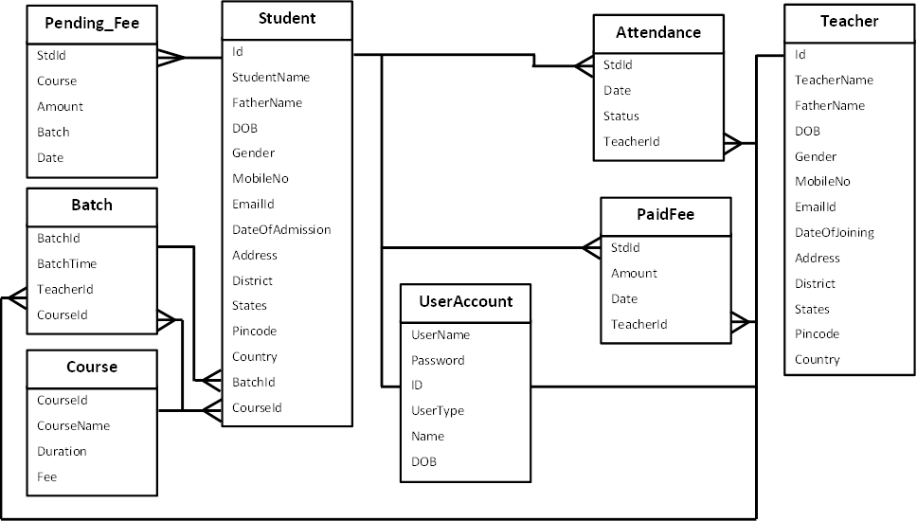

Id

StudentName

FatherName

DOB

Gender

MobileNo

EmailId

DateOfAdmission

Address

District

States

Pincode

Country

BatchId

CourseId

**Student**

Id

TeacherName

FatherName

DOB

Gender

MobileNo

EmailId

DateOfJoining

Address

District

States

Pincode

Country

**Teacher**

UserName

Password

ID

UserType

Name

DOB

**UserAccount**

StdId

Course

Amount

Batch

Date

**Pending_Fee**

StdId

Amount

Date

TeacherId

**PaidFee**

CourseId

CourseName

Duration

Fee

**Course**

BatchId

BatchTime

TeacherId

CourseId

**Batch**

StdId

Date

Status

TeacherId

**Attendance**

**Staff Management**

**View Teacher List**

**Search Teacher by Name or Id**

**Add New Teacher**

**Update Teacher Detail**

**Create username & Password**

**Student Management**

**View Student** **List**

**Search Student by Name or Id**

**Take Student Admission**

**Update Student Detail**

**Create username & Password**

**Fee Management**

**Change Course Fee**

**View Student Fee Report**

**Attendance Management**

**View Attendance**

**Batch Management**

**View Running Batch**

**Add Course in a Batch**

**Course Management**

**View Course Detail**

**Add New Course**

**Staff Management**

**View Teacher List**

**Student Management**

**View Student** **List**

**Student Detail**

**Fee Management**

**View Student Fee Report**

**Take Student Fee**

**Attendance Management**

**View Attendance**

**View Attendance**

**Batch Management**

**View Running Batch**

**Course Management**

**View Course Detail**

**Course Management**

**View Course Detail**

**Attendance Management**

**View Attendance**

**Fee Management**

**Fee Detail**

**Exam Management**

**Rule Of Examination**

**Give Exam**

**View Exam Report**

**LOGIN TYPE**

**TEACHER LOGIN**

**STUDENT LOGIN**

**ADMIN LOGIN**

**VERIFY**

**VERIFY**

**VERIFY**